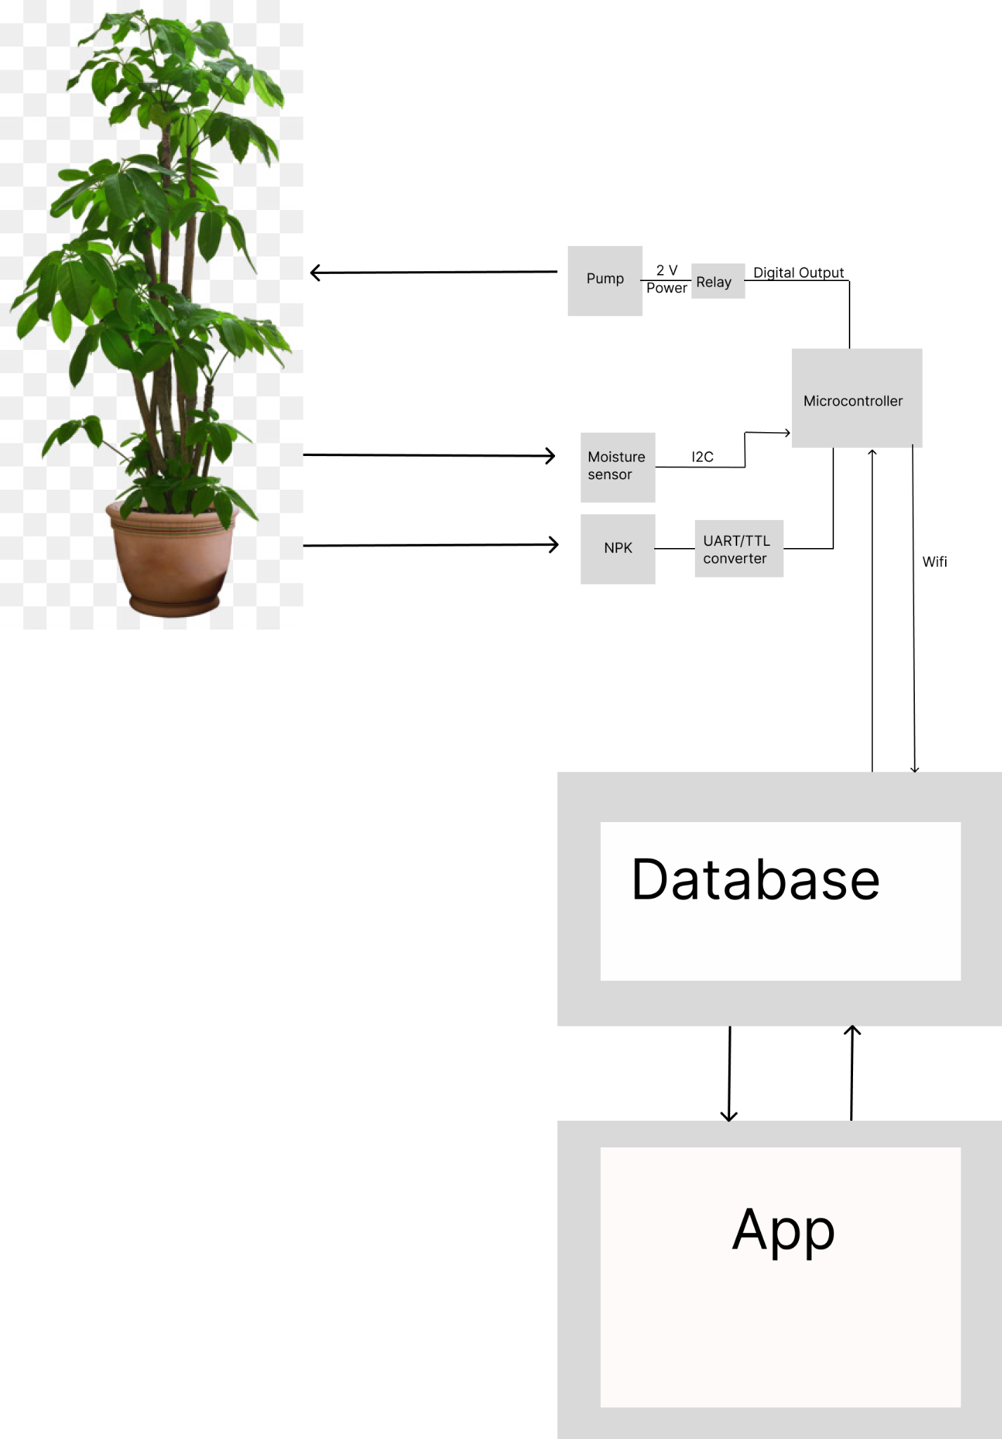

Top-level Overview:

This system describes our plant health monitoring device, which accepts data from various sensors and is then interpolated by a microcontroller and exported to a server for storage. This data is then able to be viewed on an app.

Sensors:

Moisture sensor: The moisture sensor communicates via an I2C signal reading a value between 100 and 400 to indicate the current state of moisture

NPK: The NPK sensor sends a signal based on the current amounts of nitrogen, phosphorus, and potassium in the soil; these signals are based on the Modbus protocol. To convert these signals into something legible to our microcontroller, they are sent through a TTL/UART converter. Additionally, the NPK sensor requires a twelve-volt power supply, far more than our microcontroller can output therefore, it will be hooked up to a separate 12-volt power supply.

Microcontroller: Our current microcontroller is a Raspberry Pi Pico W, internally it runs Python code utilizing mostly circuit Python to interpret the signals sent by the sensor and the Python request library to send information to the server.

Pump: The pump will be connected to a water reservoir and, when powered will dispense water at a rate depending on voltage. In order to control the power motor function, it will be connected to a one-channel relay, which will be activated by GPIO on the microcontroller. The relay will then export a 2-volt signal stepped down from the 12-volt power supply.

Database: Our current database will be hosted on an AWS server, internally it will receive RESTFul commands from the microcontroller through the use of spring boot, data will be stored through the use of my SQL database.

App: The app exists to display the data stored on the server graphically

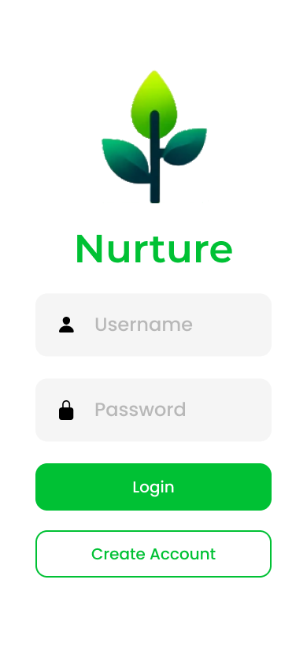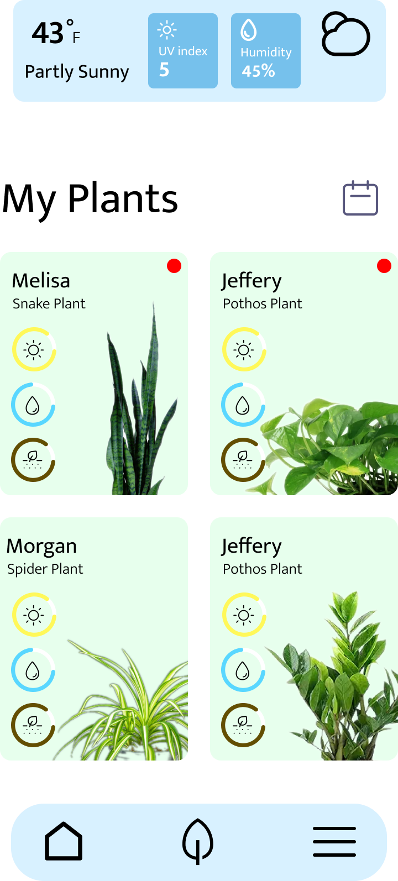

These images showcase the login and main page of the front-facing user interface. The image on the right specifically shows the current weather conditions along with each of the plants that the user has set up with our nurturing system. Each plant pane indicates basic sensor data, including sunlight intensity, soil moisture, and overall soil nutrient levels.

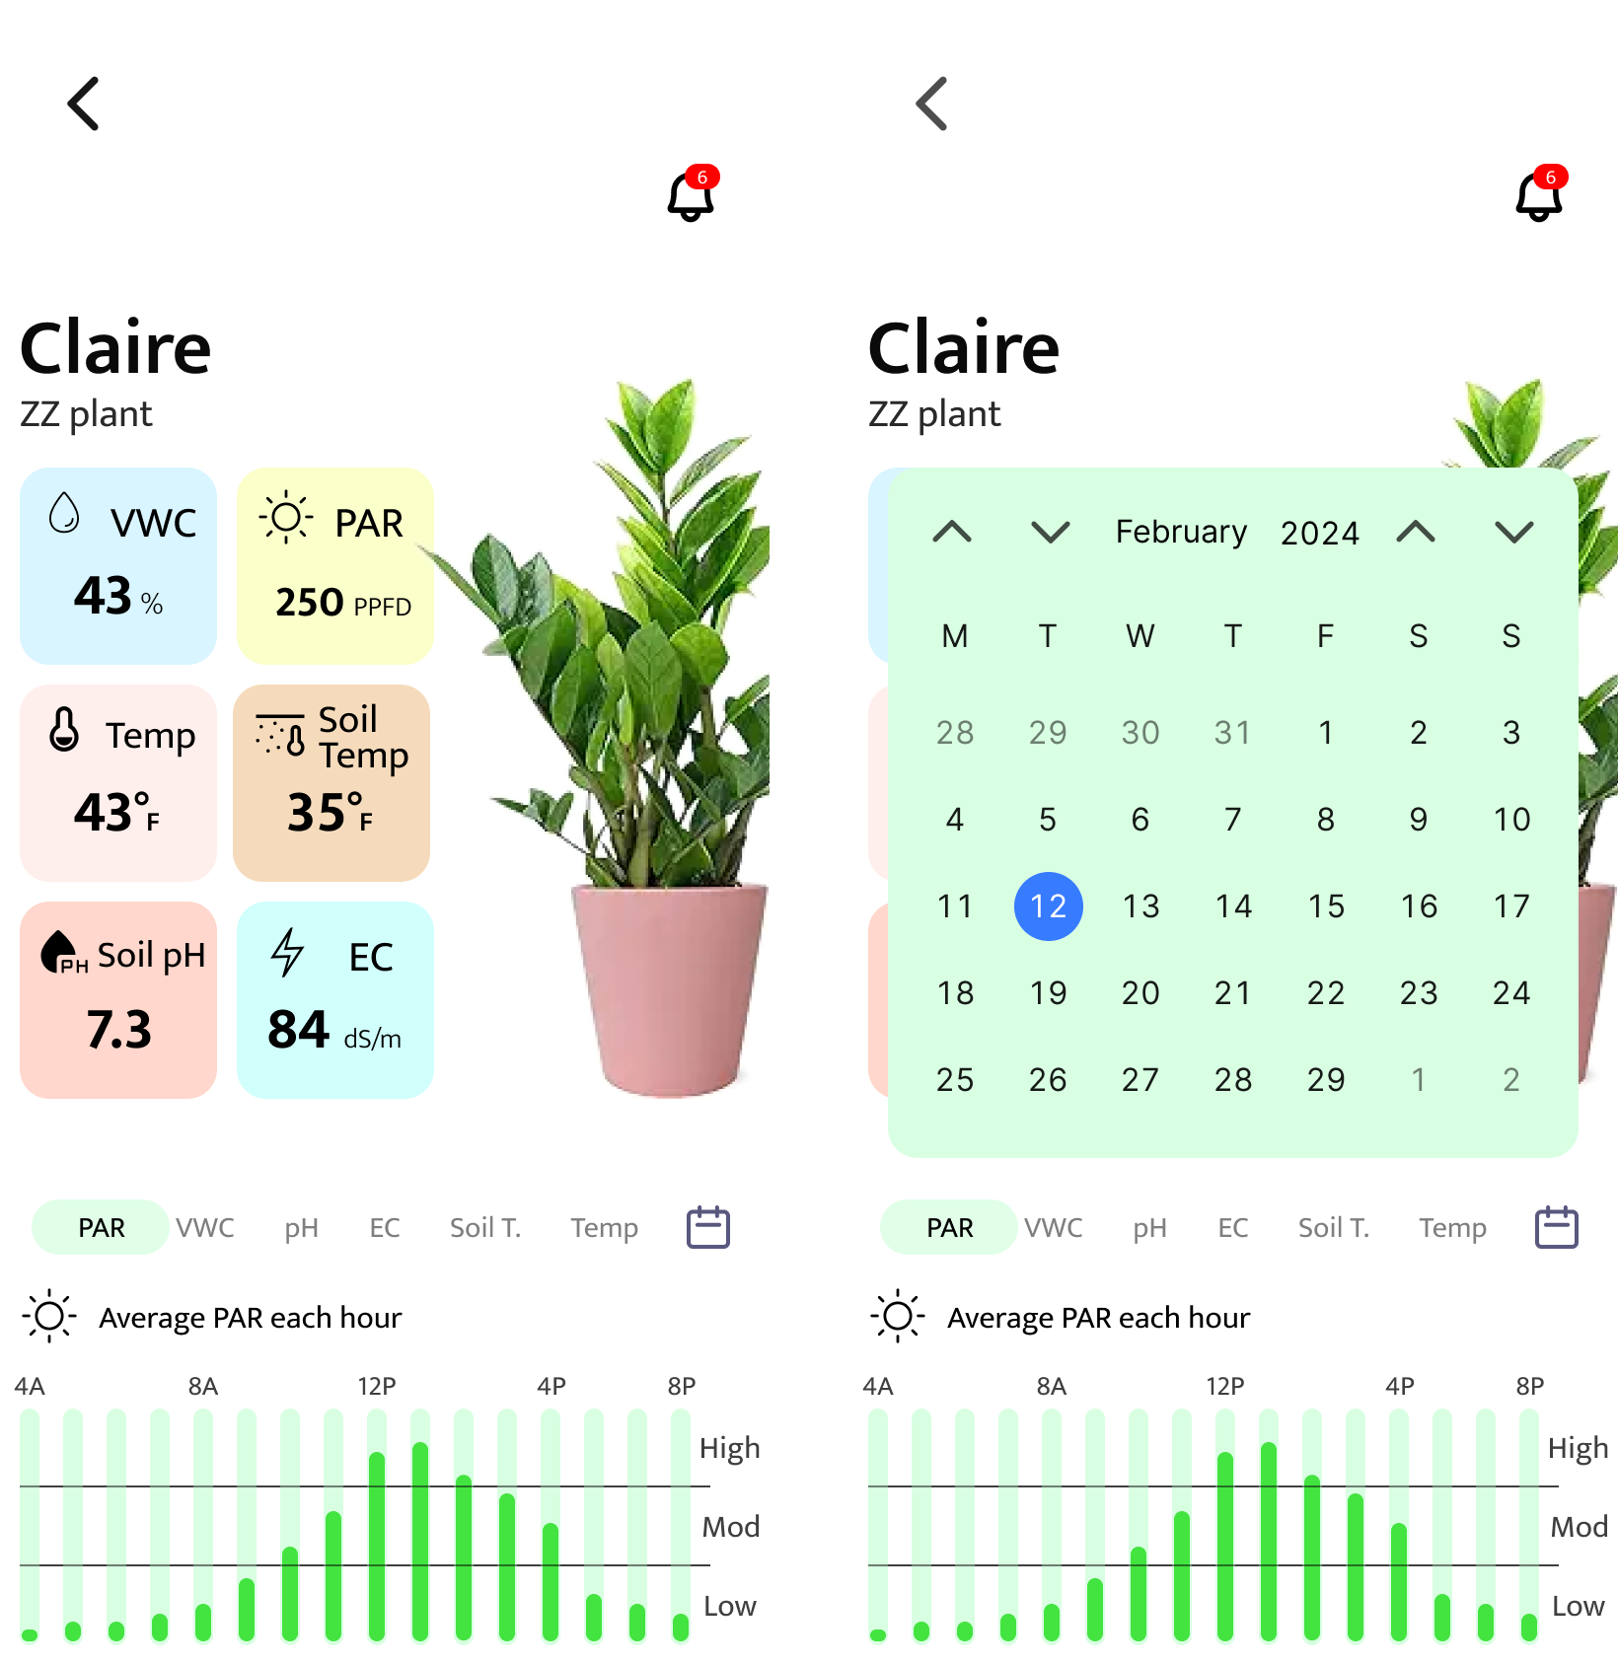

These images showcase the user interface once the user has selected a specific plant. The image on the left shows the current sensor data for that specific plant, along with a graph of a specific sensor’s data over time. The image on the right shows a calendar for the user to select a specific day to view historical sensor data.